
Software Requirements Specification
iBEX

2/14/2015
Durmaz Tek.
Istanbul-Turkey

iBEX

Software Requirements Specification

Version 2.0

Jan. 25.2015

Altay Brusan
Durmaz Teknoloji

Revision History

Date | Description | Author | Comments
04/04/2013 | Version 1.0 | Altay Brusan | Use-case specification of Access Artifact
03/04/2013 | Version 1.0 | Altay Brusan | Use-case specification of snap
25/01/2015 | Version 2.0 | Altay Brusan | Comprehensive requirement analysis

Document Approval

The following Software Requirements Specification has been accepted and approved by the following:
Signature | Printed Name | Title | Date
 | Altay Brusan | Durmaz Teknoloji

Table of Contents

Revision History ii
Document Approval ii
1. Introduction 1
1.1 Purpose 1
1.2 Scope 1
1.3 Definitions, Acronyms, and Abbreviations 2
1.4 References 4
1.5 Overview 4
2. General Description 5
2.1 Product Perspective 5
2.2 Product Functions 6
2.3 User Characteristics 7
2.4 General Constraints 7
2.5 Assumptions and Dependencies 7
3. Specific Requirements 8
3.1 External Interface Requirements 8
3.1.1 User Interfaces 8
3.1.2 Hardware Interfaces 10
3.1.3 Software Interfaces 10
3.1.4 Communications Interfaces 10
3.2 Functional Requirements 11
3.2.1 FR1 11
3.2.2 FR2 12
3.2.3 FR3 12
3.2.4 FR4 13
3.2.5 FR5 13
3.2.6 FR6 14
3.2.7 FR7 15
3.2.8 FR8 15
3.2.9 FR9 16
3.2.10 FR10 16
3.2.11 FR11 17
3.2.12 FR12 18
3.2.13 FR13 19
3.2.14 FR14 19
3.2.15 FR15 20
3.2.16 FR16 20
3.2.17 FR17 21
3.2.18 FR18 21
3.2.19 FR19 21
3.2.20 FR20 22
3.2.21 FR21 22
3.2.23 FR22 23
3.2.24 FR23 23
3.2.22 FR24 24
3.2.22 FR25 24
3.2.25 FR26 24
3.2.26 FR27 25
3.2.27 FR28 25
3.2.28 FR29 26
3.2.29 FR30 26
3.2.30 FR31 27
3.2.30 FR32 28
3.2.30 FR33 28
3.2.30 FR34 29
3.3 Use Cases 30
3.3.1 Use Case: System 30
3.3.2 Use Case: Back up 31
3.3.3 Use Case: Calibrate 32
3.3.4 Use Case: Checking 33
3.3.5 Use Case: Configuration Unit 34
3.3.6 Use Case: Logger Unit 35
3.3.7 Use Case: Manage Account 36
3.3.8 Use Case: Monitor Unit 37
3.3.8 Use Case: Print study 38
3.3.9 Use Case: Review study 39
3.3.10 Use Case: Task Organizer 40
3.3.11 Use Case: Search 42
3.4 Objects 43
3.5 Non-Functional Requirements 43
3.5.1 Performance 43
3.5.2 Reliability 43
3.5.3 Availability 43
3.5.4 Security 43
3.5.5 Maintainability 43
3.5.6 Portability 44
3.6 Inverse Requirements 44
3.7 Design Constraints 44
3.8 Logical Database Requirements 44
3.9 Other Requirements 44

1. Introduction
This document is an official artifact of the requirement analysis phase of the iBEX software platform on its second iteration. Due to major changes in system and annexation of the syncBox to the system this document is more comprehensive with regards to the previous versions.

1.1 Purpose
The aims of this document is to clarify the understanding of the developers and the users from the iBEX scope and drawing the system boundaries and requirements. For these, the document introduces the iBEX system from different point of views (i.e. technical and non-technical). It is expected that the reader (e.g. future developer or the user) could guess what the iBEX is and how it works.

1.2 Scope
iBEX is a software that is specifically developed for NDT applications. This software is a part of a general NDT system which includes: iBEX, a dedicatedly designed synchronization hardware platform which is coined syncBox, a storage server and a security dongle (Figure 1).
iBEX brings a uniform high level platform to NDT needs. Despite the fact that this software is going to be designed for x-ray based NDT, by just replacing a few software components and changing the sensor, it is possible to adapt it for other modalities like ultra-sonic NDT.
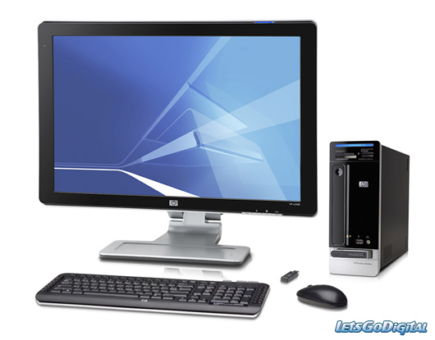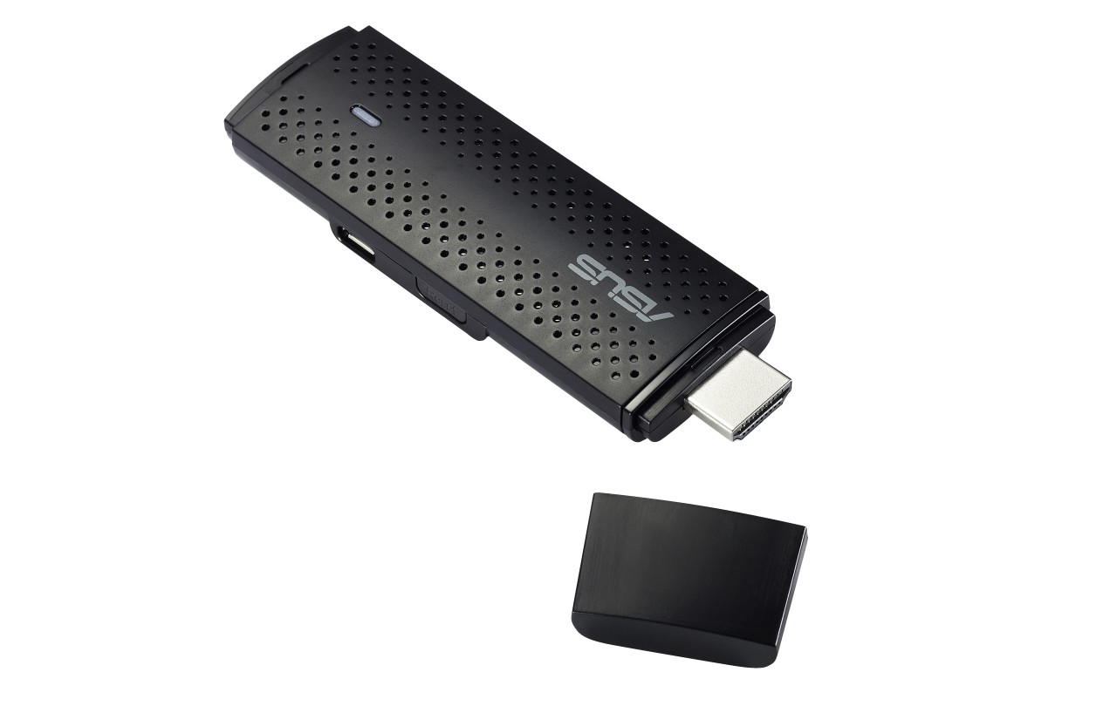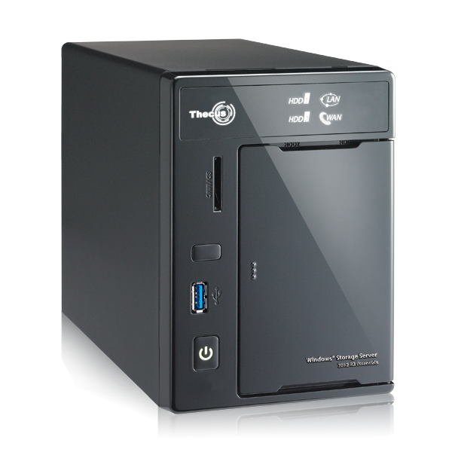
User
Work station
Security Dongle
syncBox
iBEX
Storage server
Figure 1 NDT platform parts

Figure 2 schematically shows the platform in action. The iBEX, as a part of this NDT-platform, is going to be responsible for automatic decision making, communication with syncBox, representing sensor data (e.g. representing image) and informing the user with the system status. iBEX receives data from peripheral imaging/sensing modalities, then it makes decision about the target object. It provides a graphical user interface for the user interactions, stable connection with syncBox and takes log from all critical events within the system. Finally, the iBEX lets the users to configure, calibrate and check different units.

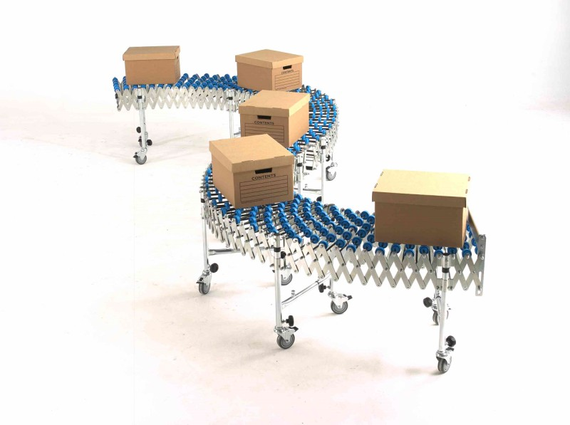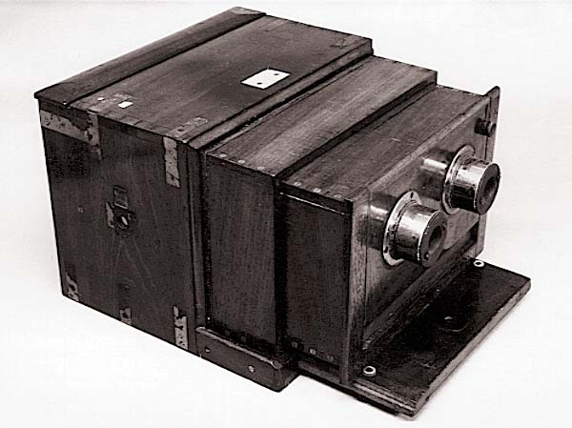
Sensor
Convey belt
Object
User
Workstation
Security Dongle
syncBox
iBEX
Storage server
Figure 2 NDT platform in action

1.3 Definitions, Acronyms, and Abbreviations

Term | Definition
NDT | Non-Destructive Test
NDE | Non-Destructive Evaluation
Sensor | Device which measures a physical aspect of an object or phenomenon and returns back an electrical quantity.
X-ray tube | A device which produces photons at x-ray spectrum
Flat panel | A device which produces digital x-ray images.
Detector | In this document, it is same as flat panel.
Work station | A device on which the iBEX is running for example a tablet, PC or smart phone
Target object | The object which is going to be tested.
SyncBox | This device is developed at Durmaz Tek. It is responsible for synchronization and controlling the peripheral devices for x-ray modality.
Power source | Any type of power source (battery, 3 phase power generator, etc.) that brings the necessary power to the x-ray tube.
P.S. | Abbreviated form of Power Source
machinery | Device which is responsible for positioning, e.g. convey belt.
Actuator | A machine which position sensor and/or tube.
Collimator | A device to shape the x-ray photon spectrum.
AEC | Automatic Exposure Control. A device controls the exposure dose and cuts the power source when enough dose is measured.
DAP meter | Dose Area Product (DAP) meter is a device that measures the product of dose and area.
Frame | Each individual x-ray image is a frame.
AI | An abbreviation of Artificial intelligence. It is unit of iBEX which is responsible for making suggestion about under test objects.
System | Workstation in conjunction with syncBox and security dongle
Peripheral devices | Any device that is externally connected to the system
User | A person how is going to use iBEX. S/He could be technician, customer crews or administer.
Unit | Each autonomous part of the system and peripheral devices is a unit.
Monitoring | A procedure in which user gets information about status and statistics
Calibration | A procedure for correcting and optimizing a unit operation
Configuration | Setting value into a unit parameter.
Checking | A procedure for measuring availability and connectivity of a unit.
Debug | A procedure to get information about events’ history.
DICONDE | Digital Imaging and Communication in Nondestructive Evaluation. Industrial revised version of DICOM.
Series | Refer to DICONDE standard [2]
Study | Refer to DICONDE standard [2]
Instance | Refer to DICONDE standard [2]
Imagıng protocol | A set of parameters (KVP, mAs, time, etc.) that specifically define an imaging technique.
The average imaging time | The total time to prepare the object to take image, exposure time and processing the data ( figure 4)
Confusion matrix | An standard way of representing performance of AI
ROC curve | An standard way of representing performance of AI

The iBEX is consistent with DICONDE standard. Some terminologies which are used in the following chapters are borrowed from this standard. Figure 3 shows a sample data hierarchy which we used. The complete list of keywords are discussed in a separate document.
Study
Series
Instance
Instance
Series
Instance
Component ID,Component Name, Study ID, Serial #
Typically based on date/time stamp, Series Description
Image or data (e.g. Tech1, Side 90 kVP, 3 mA, 5 sec)
Image or data (e.g. Tech1, top, 90 kVP, 3 mA, 5 sec)

Typically based on date/time stamp, Series Description
Image or data (e.g. Tech1, Side 90 kVP, 3 mA, 5 sec)

Figure 3 DICONDE terminology [2]

Average imaging time as it is shown in figure 4 is a measure that shows how much in average it takes an object pass through the system.
Average imaging time
Preparation time
Exposure time
Transfer and processing time
Include positioning and synchronization time
x-ray tube
Include transfer raw data to the wworkstation, AI processing and operator final desicion.
Figure 4 Average imaging time

1.4 References
[1] iBEX-Requirement analysis version 1.
[2] Standard Practice for Digital Imaging and Communication in Nondestructive Evaluation (DICONDE), Designation: E2339 − 11

1.5 Overview
The next section introduces the major components and interactions of the platform for x-ray based NDT in more details. Then the major transactions are discussed. We then see again the upper needs and requirement in more organized manner.

2. General Description
This section gives a brief introduction to the iBEX system in context and its collaborations with the other components. Then, first system user types are introduced and then constraints and assumptions are then discussed.

2.1 Product Perspective
Figure 5 shows the physical components of an x-ray based NDT. In this diagram the control lines are shown in dashed lines. SyncBox issues the synchronization and control signals and then send/receive responses from the peripherals. In addition, workstation is connected to the syncBox via a control line. In this way the iBEX, which is executing on the workstation, could get feedback from the peripherals.
The solid line is the data line. This line is used for data transfer between detector(s) and workstation. As far as x-ray images are bulky (e.g. 20MB per image or more is normal) then a separate high speed line is used to send the raw data from detector to the workstation.
Data Line
Peripheral Devices
Control Line
Work station
syncBox
Detector
machinery
Power source
Collimator
iBEX
Security Dongle
DAP meter
Grid
AEC
Alarm
Cooling & ventilation
Barcode Reader
System

Figure 5 X-Ray NDT platform

2.2 Product Functions
Table 1 lists all transactions that happen within the system. All of these transactions are initiated by the user. In other words, this table summarize all expectations (i.e. business usecases) from the iBEX from a user perspective.

Table 1 Major functionality from user’s point of view
User transaction |  | (sub)Aim
Configure internal components | Which includes configuring:
Configure internal components | - user account  - AI  - log manager |  | - syncBox  - database  - Network &PACS  - alarm
Organize project | Start new project
Review study | - view image(s)  - compare image(s)  - annotate image(s)
Monitor system | Get status information and statistics
Monitor system | - temperature,  - statistics of studies(e.g. number of taken images), |  | - statistics of power source,  - mechanical component facts,  - AI performance.
Debug system | - read log/ history files
Checking | Check:  - AI  - Database  - Network  - Connections  - PACS server
Print & Write CD | Print a study and/or write to CD
Back up | Back up database, PACS and log files
Calibration | Calibrating peripheral devices including:
Calibration | - Power source |  | - grid
Calibration | - detector |  | - DAP-meter
Calibration | - Machinery and Actuators |  | - AEC
Calibration |  |  | - cooling and ventilation
Manage imaging protocols | Define a list all protocols, make new protocol, edit, delete and update the available protocols.

Beside these, iBEX system provide some intrinsic functionalities that are not separable or disabled. Better to say, these functionalities are needed despite the fact user is not the initiator of them.

Table 2 Major functionality from system point of view
System transaction | Aim
Check dongle | Validate the dongle
Log events | Save events, error status of the system in all steps
Manage account | Provide sign in/out facility for users
Connect to PACS | Connect to DICONDE PACS server and interact with it.

2.3 User Characteristics
In this system users belong into one of the two categories: Admin & Operator. There is only one Admin account while any number of operator could be made. Admin, is the one how has full access to the iBEX systems. However, an operator has restricted access level. These limits are built into the program (e.g. hard coded) and no one has the chance of changing them.
Both user types has to sign into the system before using it. When the system is installed on a new workstation, it comes with a built in admin account with built in admin password. Then this user signs in and can change the default password. Beside this, admin can make any number of operator accounts and assign password to them. After then the other operators can sign into the system.

2.4 General Constraints
The dongle should be purchased from a trust full provider. Without the dongle, iBEX is not able to boot up. So, a well-known provider with high quality product should be considered all the time.
A USB port is used for connecting the workstation to the syncBox. So, at least one open USB port is needed on the PC. In addition, the USB driver of the syncBox should be available on the workstation.
Figure 5 shows a schematic picture of the system. In reality this scene is not as neat as it is shown. For example, AEC may be directly connected to the power source or the detector may need to negotiate with generator. Due to this priori unknown structure and connections, the system should be flexible for any change in connections and device change, keeping in mind, the syncBox is needed to handle the low level connectivity issues and the iBEX is as far away as possible from the peripheral devices’ mess up.
This document concentrates on just x-ray based NDT.

2.5 Assumptions and Dependencies
- iBEX works on Microsoft Windows (XP, 7 and 8) and based on .NET (version 4 or above) platform.
- iBEX does not boot if the dongle check is failed.
- iBEX does not boot if syncBox does not available.
- iBEX does not manage the workstation’s power. So UPS management of the workstation is out of the iBEX boundaries.
- Data line directly connects the detector to the workstation. In some cases special data transfer cards are needed (e.g. cam cards, GigE, etc.). In such situations, the iBEX is needed to have access to the card’s driver and it is in charge of data acquisition.
- Despite the fact that the syncBox is responsible for synchronization and controlling, in some brands the detector may need to receive some controlling signals via data line. So, iBEX should handle these cases.

3. Specific Requirements

This section studies the functional requirements of the previous section in more detail. The content of this section could be used to guide the project’s software design, implementation, and testing. But, this SRS is not the software design document and it does not include over-constraint (or design specification) the iBEX.

3.1 External Interface Requirements
As visual elements makes the system more comprehensible, at the first visual interfaces (i.e. GUI) and hardware connections are discussed. Then the required functionalities are discussed in more detail.

3.1.1 User Interfaces
After when the program is successfully is loaded, login page is appeared. In this step, user enters the information and if it matches, then the program continue to the main window.

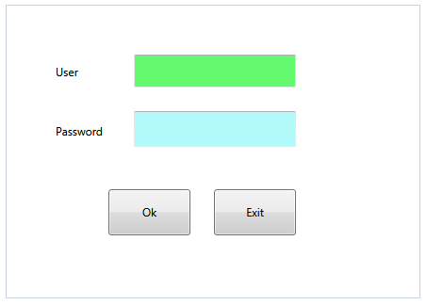
Figure 6 Log in window
If the entered information do not match, then the user can re-try or can gets out by pressing ‘Exit’ button. After then he logs into the main page (Figure 6).

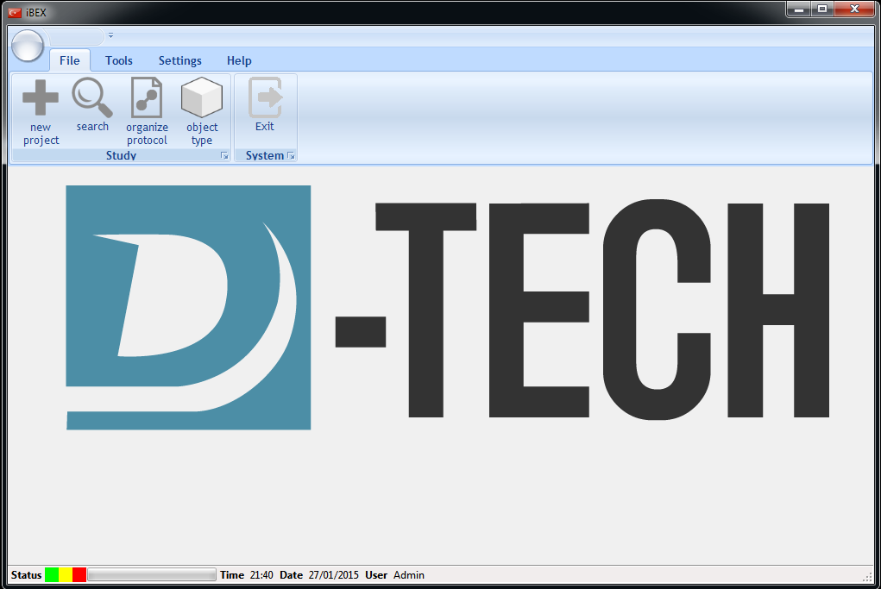
Figure 7 main menu

User transactions are categorized into three main types:

File: Study operations which includes starting new one, open/edit the existent and save the current one (Figure 7).

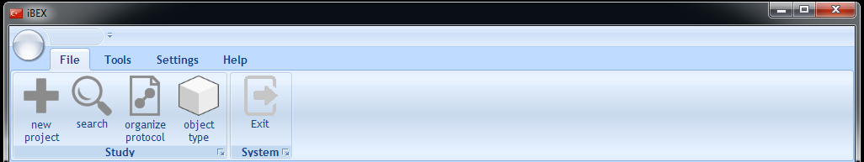
Figure 8 File operations

Tools: a tool is gadget that let the operator to: control, monitor, view or test an aspect of the system. Figure 8 shows identified tools. The iBEX is designed such that the further tools could be added in dll form (i.e. component) and at the run time the menu changes.

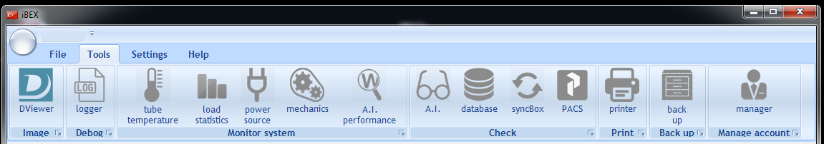
Figure 9 iBEX Tools menu

Settings: in this section user can configure iBEX components or calibrate peripheral devices. Like Tools menu, the component based architecture of the iBEX lets some specific component loads at run time and in consequence this menu changes at run time.

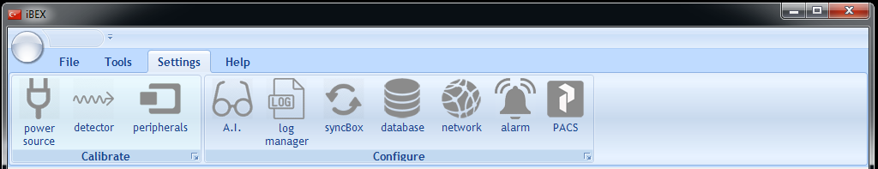
Figure 10 iBEX Settings menu

Help: User guid, dongle validation and contanct information are presented in this tab (Figure 10).

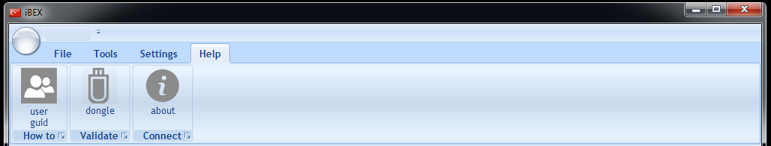
Figure 11 iBEX Help menu

3.1.2 Hardware Interfaces
The iBEX does not load if security dongle or syncBox failed to load. Barcode reader, if it is needed, will be connected to the syncBox. The other connections are discussed in the previous chapter.
The system is based on pre-selected dongle. Automatically after system starts up Dongle checking is started. Dongle change requires to change the whole tool.

3.1.3 Software Interfaces
The iBEX is in need of a PACS server for handling the database operations. Beside this network connections and management is also the task of PACS server. iBEX has just partial control over the parameters, for example machine IP address.

3.1.4 Communications Interfaces
Communication media between syncBox and iBEX is via USB.

3.2 Functional Requirements
This section describes functionalities of the system. These functionalities may be imitated by a user or the ibex itself. These functionalities are aimed to satisfy the user transactions (Table 1) and system transactions (Table 2). Some
This section describes specific features of the software project. If desired, some requirements may be specified in the use-case format and listed in the Use Cases Section.

3.2.1 FR1
Use Case Name | Read log file
Introduction | All events happened within the system are recorded in a few log files. Admin reads log files but cannot make change on the log contents or change the files format, after it is set for the first time.  The system must provide a way for admins to read the log contents.
Trigger | The admin presses the Tools> Read log button.
Inputs | A log file on which the system history is recorded.
Processing | - Admin select the log file.  - The system checks the log manager for the file location.  - The system loads the file and interpret it if it is XML type.  - The log file is represented.
Outputs | Nothing
Post condition | Nothing
Error Handling | If the file does not exist after a warning message, the situation is informed to the user. If it is approved a new log file is made.  The log file error cannot stop system from working.
Other | Logs are kept in one of the two formats: XML or TXT. In both file formats, the general style of recording would be:  <TAG> DESCRIPTION </TAG>  Tags could be one of the followings:  - START  - SUCC_LOG_IN  - UNSUCC_LOG_IN  - WARNING  - ERROR  Each of which has a specific corresponding description format  - DATE TIME  - DATE TIME USER_NAME  - DATE TIME USER_NAME  - WARNING_CODE DESC.  - Error_CODE DESC.

3.2.2 FR2
Use Case Name | Manage the logger
Introduction | When the system is set up for the first time some default values for log files location and their types (TXT or XML) are selected. The admin can change this location to somewhere else on the workstation. This is useful when the log file size is increased and search inside the file reduces the system response time or there is not enough space in one hard drive and logs are needed to be saved somewhere else.  Under any circumstance, the logging facility of the system is possible to turn down.  The system must provide a way for admins to change the logger unit’s configuration.
Trigger | The admin presses the Tools> Manage log button.
Inputs | Destination folder and file formats.
Processing | Log manager window appears. For each log file a destination and file format is possible to be selected. If this location is same as the previous one, a warning appears which says “The previous log file content maybe deleted or its content will not be accessible, are you sure? If the user approves then the file is overwrites the existing file.
Outputs | Save the log file format and location into system variables.
Post condition | Logger configuration is updated.
Error Handling | If any file error happens then the user is informed by “No history would be kept” but system still continuous with its normal operation.
Other | Refer to FR1

3.2.3 FR3
Use Case Name | Take log
Introduction | The system takes log from all events happening within the system. This events include all warnings, errors and transactions.
Trigger | Any important event.
Inputs | Logging location and file formats.
Processing | Save the events into the log file.
Outputs | Log file
Post condition | Nothing
Error Handling | If access level is violated, destination folder does not exists or there is not enough space to write into, file is opened by another program, then the user should be informed with situation and asked to solve it. Otherwise, no event would be kept but the system continue.
Other | Refer to FR1

3.2.4 FR4
Use Case Name | View study
Introduction | The user can open, edit, annotate, print and compare studies (DICOM files) which are already taken. These studies maybe selected from storage server or local drive, for example a DICOM file which is taken by iBEX. In the first case, the studies are queried from storage server but in the latter case the user locates the file location on local storage.  The system must provide an image viewer.
Trigger | The user press’s Tools>Image viewer button.
Inputs | Destination studies.
Processing | First the image viewer tool main window shows up and then user locates the target studies. The tool loads the studies and shows the contents (e.g. images, waveforms) of the studies. User annotate and manipulate or compare studies. When the user finished up; by means of pressing save button or closing the image viewer a warning appears and ask if the user wants to keep the changes or not? If it is approved then the destination is requested. If it is same as the already opened, then a warning indicating “over writing” shows up. If this one also approved again then the image is over written.
Outputs | Transactions (completely or partially are saved) into log file(s). If any change is made then, the updated study is over-witted.
Post condition | Opened study information is saved into log file.
Error Handling | Access level violation,  Corrupted file  not enough space to write into,  File is opened by another program,  PACS connection failure.  User is informed with situation and asked to solve it. A log event is saved.
Other | Refer to FR1

3.2.5 FR5
Use Case Name | Print study
Introduction | The user can print a study (DICOM file). These studies may be loaded from PACS or local storage. In the first case, the studies are queried from PACS server but in the latter case the user locates the file location on local storage.
Trigger | The user press’s Tools>Print button.
Inputs | Destination study.
Processing | - The user locate the target study  - The contents are shown on the screen.  - User selects which instances should be printed.  - The selected instances are printed.  - The metadata is also represented.  - User can also print the metadata separately.
Outputs | Printed form of studies.
Post condition | Nothing.
Error Handling | Access level violation,  Corrupted file  PACS connection failure.  User is informed with situation and asked to solve it. A log event is saved.
Other | Refer to

3.2.6 FR6

Use Case Name | Back up
Introduction | iBEX keeps the data flow in the system in three ways:  inside database  storage server  log file  Admin can take back up in three ways:  - Log file back up: Copy a log file to a location inside the local storage on the workstation  - Partial backup: a few studies are loaded from PACS server to workstation and then the user can copy it to flash disc, CD or external hard disc.
Trigger | The user press’s Tools>Back up button.
Inputs | Depends on back up program:  - Log file backup: Log file and destination location.  - Partial back up: requested studies and their identities.  - Full back up: depends on PACS server and database configurations.
Processing | Log backup: Admin selects a log file and destination. The log file content is copied to the destination location.  Partial backup: admin identifies the required studies and destination location. iBEX gets these studies from storage server and then copy them to the destination location.  Full back up: all database and storage server contents are copied.
Outputs | Copy of partial/full contents of storage server and/or log file(s).
Post condition | Nothing.
Error Handling | Access level violation,  CD write errors.  Too many studies are selected and system is over loaded.  Corrupted file  not enough space to write into,  File is opened by another program,  PACS connection failure.  User is informed with situation and asked to solve it. A log event is saved.
Other | Refer to …

3.2.7 FR7

Use Case Name | Manage accounts
Introduction | A new user is made or the user password is updated by the admin.
Trigger | The user press’s Tools>account manager button.
Inputs | Account information.
Processing | admin can create a new account. In this case the account name and password are needed.  User can change the existing accounts password. In this case the new password is entered.  iBEX keeps this account information on database.
Outputs | New account information is saved into database or existing information is updated
Post condition | Nothing.
Error Handling | Access level violation,  Account does not exist  User is informed with situation and asked to solve it. A log event is saved.
Other | Refer to …

3.2.8 FR8
Use Case Name | Monitor Temperature
Introduction | The temperature is important in system performance, especially the tube temperature. Some devices come with detector temperature sensor too. The user needs to check out the system temperature.
Trigger | The user presses the Monitor> Temperature button.
Inputs | The system reads the temperature from the peripherals. These values are the input. The most updated value is come from peripherals and the previous ones are read from log files.
Processing | Via syncBox the most updated temperature status is achieved. In addition the history of the temperature’s status are called from the log file and then shown on GUI.
Outputs | Nothing.
Post condition | Nothing.
Error Handling | If there were any problem in connecting, reading or processing (like big ending or small ending) then an error message appears and clarify the situation. Log file errors are also possible.
Other

3.2.9 FR9

Use Case Name | Monitor Load Statistics
Introduction | User starts to get some statistics from different aspects about studies that already accomplished till now. For example the operator may want to know :  - How many images are taken in a specific period?  - How many specimens is tested in a specific period?  - [How many meters of pipe is scanned?]  - What is the average energy per image/specimen?  - What is the average imaging time per image/specimen?  - How many images are taken from each object type?  - What is the system usage time in average?  - What are the acceptance and rejection ratios of each object type for specific period of time?  - What is the dosage per specific period of time?
Trigger | The user presses the Monitor> Load statistics button.
Inputs | With respect to question, appropriate commands are sent to the database and/or PACS server. The returned numerical values are then used to calculate the aimed quantity.
Processing | The processes depends on the question; however, it is usually mathematical operation.
Outputs | Representation on GUI and no data is saved on the original source.
Post condition | Nothing
Error Handling | Making connection to database/ PACS is a possible to face error. Also, data processing should be done in reliable way. In any case, any error is saved into a log file and a message is shown on the screen over load.
Other | Refer to …

3.2.10 FR10

Use Case Name | Monitor Power Source
Introduction | The power source may change from a device to device. Battery, three phase generator, single phase (old machines) and inverter based generators are mainly used in current devices. The details of the device depend on the model and manufacturer. So, it is not easy to enlist what information a user could get from power source. The following list is a good candidate:  - The power source name  - The power source serial number  - The power source status  - The power source connection type (for example RS232)  - The power source error status (directly ask from generator)  - The power source error history (comes from log file)  - If the power source is battery: the remained power
Trigger | The user presses the Monitor> Power Source button.
Inputs | Status information from generator and log file.
Processing | Connect to the database and ask for the most updated status. Then load the appropriate log file to get the previous status information. If the log file keeps the history of the events that are not related to the power source, then, the power source related information should be excerpted.
Outputs | Representation on GUI and no data is saved on the original source.
Post condition | Nothing
Error Handling | Feasible errors are:  Making connection to power source  Power low,  Power source does not response  In any case, any error is saved into a log file and a message is shown on the screen.
Other | Refer to …

3.2.11 FR11

Use Case Name | Monitor Machinery and Actuators
Introduction | If iBEX were considered as the top boundary of the system and the syncBox in the middle then the machineries and actuators are the lowest boundary of the system. They are divided into two categories:  Mounted: The machines and actuators are installed over some other existing electro-mechanical components, for example convey belt. In this case the system may has no control/ connections to the existing components. For example, consider a factory with a convey belt in production line which is controlled by a Siemens PLC. So, making any connection to the Siemens PLC requires special agreement with Siemens at first, if it is not possible to have such contract, then there will be no integration between convey belt and the system.  Designed: despite the previous case, the machines and actuators are designed from sketch and installed in site. In this case, the system is fully integrated into the mechanics.
Trigger | The user presses the Monitor> Machinery and Actuator button.
Inputs | Updated status information from mechanics and previous status from log file.
Processing | Making connection to the machinery unit and asking for the status.  If the log file keeps the history of the events that are not related to the machineries and actuators, then the relevant information must be excerpted.  In any case system should be stopped.
Outputs | Representation on GUI.
Post condition | Nothing
Error Handling | Feasible errors are:  Making connection to mechanisms  Power low,  Mechanism does not response  In any case, an error is saved into a log file and a message is shown on the screen.
Other | Refer to …

3.2.12 FR12

Use Case Name | Monitor AI Performance
Introduction | A.I. unit takes the instances of a series in a study, analyzes them, put some annotation and then suggests “accepted” or “rejected”. This unit also can make a decision for each instance (image taken from an object) and then based on each decision makes an overall suggestion for the object.  The user can monitor how the performance of this unit was over the previous studies. The user can monitor the performance from three points of views:  - How did the AI perform on a specific object type?  - How did the AI perform on a specific object?  - How did the AI perform in specific time period?  - How did the AI perform based on applied protocol?
Trigger | The user presses the Monitor> AI performance button.
Inputs | AI decisions are kept in database. These information are asked from the database. AI enable/disable is asked from system variables.
Processing | First AI, enable/disable is asked from the system variables. If it was ‘enabled’, then information are loaded from database and processed. The results are shown in:  - Confusion matrix  - ROC curve
Outputs | Representation on GUI. The user can also print out the results.
Post condition | Nothing
Error Handling | In some cases the AI unit may not work or deactivated on purpose:  - Limited license with no AI.  - Increase the system speed by deactivating the AI by user  - No need to AI  The monitor > AI performance is disabled automatically.
Other | Refer to …

3.2.13 FR13
Use Case Name | Checking AI Unit
Introduction | The user may want to check the AI by means of asking the AI unit to perform over a set of off-line studies.
Trigger | The user presses the Checking> AI Unit button.
Inputs | The user locates an image(s) from PACS server or local storage device. Then this studies are sent to the AI for analysis.
Processing | AI operation on the image
Outputs | Acceptance/rejection by AI.  AI annotations.
Post condition | User can see the AI outputs on images
Error Handling | AI is not activated.  PACS does not response.  Images are not valid format.  Too many images are asked from PACS.  In any case, any error is saved into a log file and a message is shown on the screen.
Other | Refer to …

3.2.14 FR14

Use Case Name | Checking Database
Introduction | User wants to check if the database is available or not. If not the connection is refreshed.
Trigger | The user presses the Checking> Database button.
Inputs | Database parameters loaded from system variables.
Processing | If a connection exists and works then a success message is shown on the screen. Otherwise, the connection is refreshed.  Then some dummy materials are send to the database and then deleted. In each step, appropriate message is represented to the user and status is saved into the log file. This usecase may also need PACS checking.
Outputs | Show the status on the screen and save it into the log file.
Post condition | nothing
Error Handling | Database connection error for example the database service is turned down or crashed. In this situation, information related to the status is shown to the user and event logs are taken.
Other | Refer to …

3.2.15 FR15

Use Case Name | Checking PACS
Introduction | User checks the PACS connection. The user also send a dummy (test) study to PACS server and check if it is written and reloaded back.
Trigger | The user presses the Checking> PACS button.
Inputs | AE, IP address and port name are loaded from system variables.
Processing | At the first the network connection is checked. Then if connection to PACS exists and works then a success message is shown on the screen. Otherwise, the connection is refreshed.  Then a dummy study is sent to the PACS and deleted. In each step, appropriate message is represented to the user and status saved into the log file. This usecase may also need database checking
Outputs | Show the status on the screen and save it into the log file.
Post condition | Nothing
Error Handling | PACS connection error
Other | Refer to …

3.2.16 FR16

Use Case Name | Checking Network
Introduction | In order to archive the accomplished studies a PACS server is used. The device on which the PACS server is running is known storage server. In practice, the storage server is a machine other than workstation. The connection between workstation and storage server is based on DICOM standard. This standard, is based on TCP/IP protocol.  If the user wants to check the PACS availability, first has to check if the network connection is available or not.
Trigger | The user presses the Checking > Network button or Checking > PACS button.
Inputs | IP address and port name.
Processing | A ping is sent to the target IP machine.
Outputs | Show the status on the screen and saved into log file.
Post condition | Nothing
Error Handling | PACS connection error. In this situation, information related to the status is shown to the user and event logs are taken.
Other | Refer to …

3.2.17 FR17
Use Case Name | Checking Connection
Introduction | User wants to check how the ports are mapped during system setup.
Trigger | The user presses the Checking> Connection button.
Inputs | Setup parameters loaded from system variables and history of the connections statues are excerpt from a log file.
Processing | From the system variables appropriate parameters are loaded and displayed. In some special cases some dummy massages is also possible to send to check if there is any response or not. In this way, the existence of the connection is also checked. But despite the, device checking or monitoring, the aim is not the device itself but it is the connection line.
Outputs | Connections status is shown to the user
Post condition | nothing
Error Handling | Connection error.
Other | Refer to …

3.2.18 FR18

Use Case Name | Calibrate Power Source
Introduction | User wants to calibrate the power source.
Trigger | The user presses the Calibrate> Power Source button.
Inputs | Calibration parameters: these parameters depends on the power source itself.
Processing | If the power source is calibrate-able, then these parameters could be sent to the power source. However, the better solution is to just show the calibration parameters and encourage the user to calibrate the power source by means of tools that come with power source.
Outputs | Show the status on the screen and save it into a log file.
Post condition | Power source is calibrated
Error Handling | Power source calibration is a serious task any error could be non-reversible!
Other | Refer to …

3.2.19 FR19

Use Case Name | Calibrate Detector
Introduction | Detector usually comes with some files that are used during imaging. For example “map file”, “defect”, “dark image” and “white image”. When the user calibrates the detector some of these files are updated. For example, a black image under no exposure is captured and used as dark image. The complete procedure and files depend on the detector itself.
Trigger | The user presses the Calibrate> Detector button.
Inputs | Files that are supported by the detector manufacturer and/or images that are taken under specific condition.
Processing | User takes white/black images. The procedure depends on the detector type. The instruction is shown on the screen and the user goes exactly based on that.
Outputs | Calibration files that are saved in specific location
Post condition | Nothing
Error Handling | Calibration error: ask technical staffs.
Other | Refer to …

3.2.20 FR20

Use Case Name | Calibrate Peripherals
Introduction | User wants to calibrate the AEC, DAP meter, Grid, barcode reader, cooling and ventilation or machinery and actuators. Usually the system has little control over them. The configuration procedure is described on the device manual.
Trigger | The user presses the Calibrate> Peripherals button and then select the device tab.
Inputs | Calibration parameters depend on peripheral.
Processing | The calibration instruction is shown on the screen. User goes through that step by step.
Outputs | Status and all events are saved into the log file.
Post condition | Nothing
Error Handling | Calibration error: ask for help from technical staffs.
Other | Refer to …

3.2.21 FR21
Use Case Name | Configure Network and PACS
Introduction | User wants to configure the network connection parameters. This connection is between the storage PACS server on storage machine and iBEX on workstation. After configuring the connection then the PACS parameters are configured.
Trigger | The user presses the Configure> network and PACS button.
Inputs | IP address, port number and AE of PACS
Processing | First the connection is checked, then the parameters are set to the values given by the user. A copy of configuration parameters are saved into system variable and finally the system status is saved into a log file.
Outputs | Status are saved into a log file.
Post condition | Nothing
Error Handling | Network error: in this case system is stopped from working.  PACS error: in this case system is stopped from working.
Other | Refer to …

3.2.23 FR22
Use Case Name | Configure Alarm
Introduction | Abnormal situations and messages are reported to the user by three means:  - Error message on workstation display and/or syncBox,  - sound  - alarm light  User can configures these alarms parameters.
Trigger | The user presses the Configure> Alarm button.
Inputs | Alarm devices parameters:  Sound: Sound frequency and sound volume
Processing | The iBEX sends the error information to the syncBox and keeps a copy to system variable.
Outputs | Status and system configuration is updated.
Post condition | Nothing
Error Handling | unknown
Other | Refer to …

3.2.24 FR23
Use Case Name | Configure SyncBox
Introduction | Each peripheral device comes with a set of specific connection parameters. For example a generator may need 14400 baud rate, however, another generator may need 9600 baud rate. Beside this the port number on which the generator is connected is determined during the system setup. After completing the system set up this types of information are entered into the system variable. The iBEX needs to send this information to the syncBox.
Trigger | The user presses the Configure> syncBox button.
Inputs | System setup parameters.
Processing | The iBEX is connected to the syncBox via a USB port. By means of this channel, the iBEX sends a special request to the syncBox and asks for configuration. The syncBox responses with an ACK message. Then iBEX sends the configuration parameters to the iBEX.
Outputs | Nothing.
Post condition | SyncBox configured
Error Handling | SyncBox error in configuration and connection to the syncBox.
Other | Refer to …

3.2.22 FR24
Use Case Name | Configure Database
Introduction | Some database parameters are needed to be changed or updated. In this case Admin can configure database configuration.  System must provide database configuration facility to the Admin.
Trigger | The user presses the Configure> Database button.
Inputs | Database parameters.
Processing | The Admin enters the parameters. The iBEX updates the database parameters and if it is needed refreshes the database.
Outputs | Nothing.
Post condition | Database reconfigured.
Error Handling | Database configuration depends on the database vendor. If any error in updating the database happened it should be reported to the user and asked to recheck the configurations.
Other | Refer to …

3.2.22 FR25

Use Case Name | Configure AI
Introduction | System must provide AI configuration facility to the Admin.
Trigger | The user presses the Configure> AI button.
Inputs | AI parameters.
Processing | The Admin enters the parameters. The iBEX updates the database parameters and if it is needed refreshes the AI.
Outputs | Nothing.
Post condition | AI reconfigured.
Error Handling | AI configuration depends on the AI module and its configuration. If any error in updating the AI unit happened it should be reported to the user and asked to recheck the configurations.
Other | Refer to …

3.2.25 FR26
Use Case Name | System Set up
Introduction | The system is purchased and it is going to be installed for the first time on the site.
Trigger | Set up system in site.
Inputs | Workstation, iBEX, dongle, peripherals and syncBox.
Processing | Cables are connected, user accounts are made, network is adjusted, and mechanical components are calibrated. PACS server is installed. Then the setup configuration is informed to the iBEX. After then the iBEX sends (some of the) information to the syncBox. Finally, the setup parameters (e.g. port map) are saved into system variable.
Outputs | System is ready to launch.
Post condition | This requirement may also need collaboration with PACS test.
Error Handling | Any of the setup errors.
Other | Refer to …

3.2.26 FR27
Use Case Name | System evaluation
Introduction | The system is already set upped, configured and calibrated. Customer wants to see the operation of the device in place. Also, any possible integration error is needed to be identified. Some evaluation objects (or phantoms) are selected randomly and fed into the system.
Trigger | The user starts new project
Inputs | Complete study information form.
Processing | System works on the evaluation objects.
Outputs | Evaluation performance chart and customers opinion
Post condition | If the final results are satisfactory then the installation is completed.
Error Handling | Any integration error revealed and solved.
Other | Refer to …

3.2.27 FR28
Use Case Name | Start new project
Introduction | The system is already set up successfully and ready to use. The user starts a new project. For one of the following two reasons  Starting a new study:  Indeed, each study is equivalent to a real object under test. For example, an object of type A gets under the x-ray tube; the instances (in x-ray NDT these instances are x-ray images, but in ultrasonic devices it could be waveform) are collected. These instances (accompanied by some meta data) are encapsulated into a DICOM file and send to PACS server on storage management for achieving.  Special purpose images:  In some situations user needs to take special images. For example during calibrating detector, the user needs to take some dark image with no exposure or white image under specific exposure parameters. In this cases the taken images may need to be stored into a specific location but not into the PACS server.
Trigger | The user presses File > new project button.
Inputs | The new project parameters which includes:  - Operator name  - Date  - Object programs  - End condition
Processing | On the new study window, the user selects the object types and the end condition of each of the object types. Beside this some environmental parameters, like user name and date are read from system variables and automatically filled in the locations. User cannot change them.
Outputs | New study. It is partially saved in Database and PACS
Post condition | Image viewer in new study container appears.
Error Handling | A unit may not work. Then new project is not enabled.
Other

3.2.28 FR29
Use Case Name | Search study
Introduction | The user needs to search for a specific study. The condition may:  - Operator  - Date and/or Time of study  - Object barcode  - Energy level
Trigger | The user presses File > search study button
Inputs | Information stored in database and PACS
Processing | The user gives the specification of the study. An appropriate commands are produced and then sent to the PACS and database. The returned outcomes, first enlisted and presented to the user and then if the user double clicked on an entity on the list the image viewer would open up and show the images content of the study.
Outputs | If the study found the information is represented. If not then an error message is shown.
Post condition
Error Handling | PACS and database error  User may ask for a broad range of studies. For example the user may ask for whole the information content of the PACS server, this could crash the system and should be prevented before ahead.
Other | Refer to …

3.2.29 FR30
Use Case Name | Organize protocols
Introduction | By means of this usecase the user is able to  - Define new protocol  - Edit existing protocol  - Update a protocol  - Delete a protocol  - Save protocol  - List protocols
Trigger | The user clicks on File> Organize protocol
Inputs | Existing protocols on the system (available on either database or XML file).
Processing | Available protocols are enlisted, user can then select one of them in the list and manipulate it. Then by pressing update button the new values are over written. If the user wants to define a new protocol, at first a new protocol button is pressed then the new protocol window appears. Then the user enters the new protocol specification and save it.
Outputs | Protocol list (XML file which is saved in iBEX location or protocol table which is saved in database)
Post condition | A Protocol(s) is updated.
Error Handling | If the protocols are saved in XML file, these file may by manipulated or deleted accidentally out of the iBEX.  In this case a fatal error should be announced and user should be asked to solve it at first.  If the protocols are saved with in the database then connection error is feasible. In this case, the user should be warned by fatal error and describe the situation and asked to update the protocol table.
Other | The following is the structure. This structure is flexible enough to encompass all the different types of protocols.  <Protocol Name, Protocol Parameter>  Protocol Parameter:  < "TYPE", value>  TYPE  - Collimator  - Generator  - Detector  - Machinery.  - AEC  - Communication.

3.2.30 FR31
Use Case Name | Organize object type
Introduction | In NDT site, different types of objects may be tested. Before starting a new project or study these types of objects must be introduced to the iBEX. For this aim, the user can organize object type. By this mean the user is able to  - Define new object type(s)  - Edit existing object type(s)  - Update existing object type(s).  - Delete an object type  - Save object type
Trigger | The user presses File > organize object type button
Inputs | Object type parameters (for example name, size, UID, etc.) are stored in database
Processing | First the object type window is appears. The user select how many object types exists. Then for each object type determines the parameters.
Outputs | Object type parameters are stored into database
Post condition | Nothing.
Error Handling | Database connection error.  Object already exists
Other | Refer to …

3.2.30 FR32

Use Case Name | Dongle check
Introduction | In order to have iBEX work correctly a security dongle is needed. This dongle is purchased from a third party. When system is loading, the dongle is checked.
Trigger | System booting up.
Inputs | Dongle security information which is stored in system variables.
Processing | When system is loading iBEX connects to the dongle and check its existence and validate the security code. If this step is approved then system continues with its operation
Outputs | Nothing
Post condition | Depends on validation result, either system boots up or fails and does not boot.
Error Handling | If validation fails then an error message appears and user is asked to check the dongle.
Other | Refer to …

3.2.30 FR33

Use Case Name | Certify system
Introduction | After successful loading, user can check system certification. This certification are mostly related to dongle
Trigger | The user clicks on Help> Certification
Inputs | System version and other certification information.
Processing | Dongle information is loaded from system variables and shown to the user.
Outputs | Dongle related information
Post condition | Nothing.
Error Handling | Certification error is critical!
Other | Refer to …

3.2.30 FR34

Use Case Name | Help
Introduction | User can get assistance in two ways:  Read the manual  Contact technical stuffs..
Trigger | The user clicks on Help> help or Help > contact us
Inputs | Nothing
Processing | User manual is installed when the system is set up. The user can open it up and read it or can directly contact a technical staffs.
Outputs | User manual.
Post condition | Nothing.
Error Handling | User manual may be deleted accidentally out of iBEX. In this case an error message appears on the screen.
Other | Refer to …

3.3 Use Cases
Some major usecases are identified and represented in this section.

3.3.1 Use Case: System

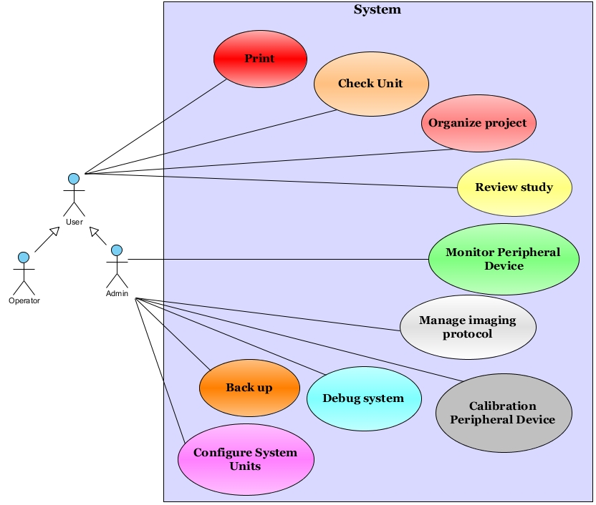

3.3.2 Use Case: Back up
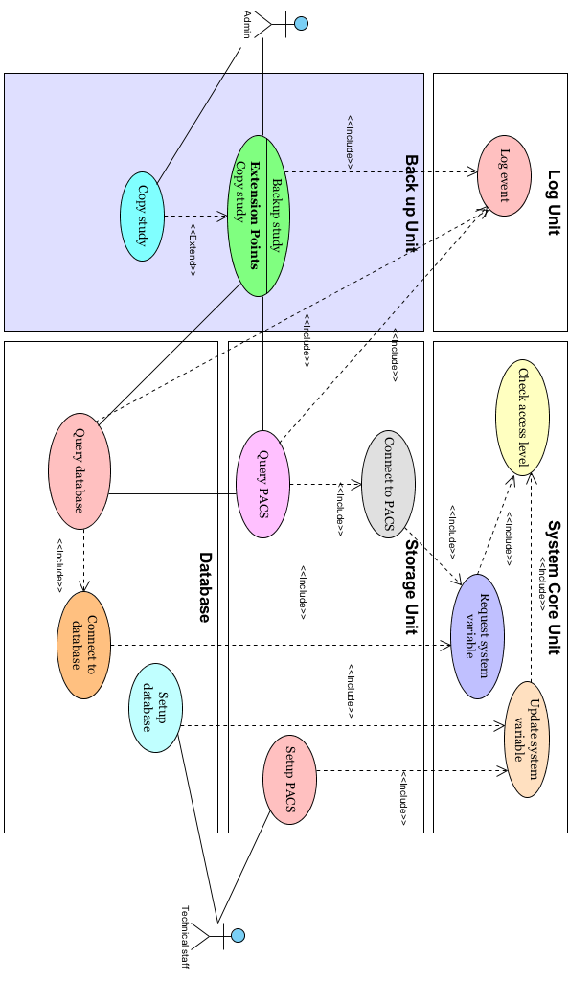

3.3.3 Use Case: Calibrate

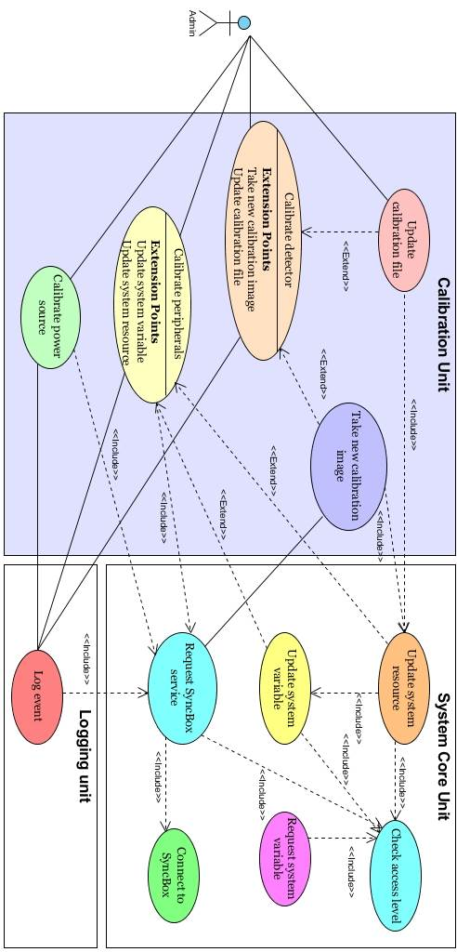

3.3.4 Use Case: Checking

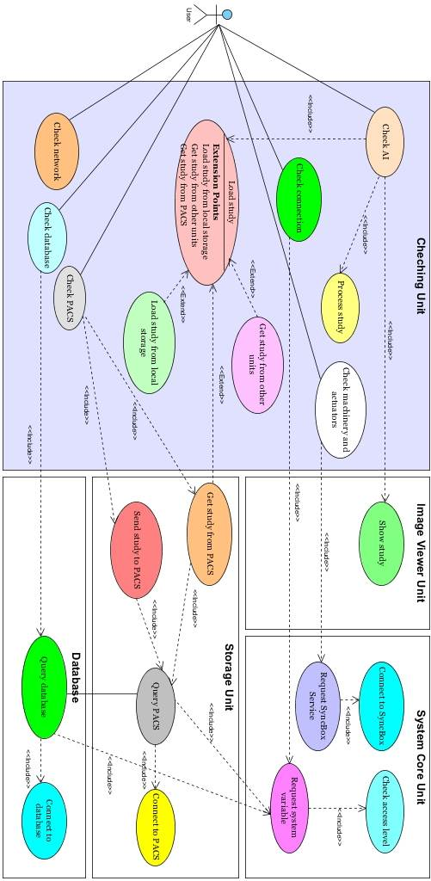

3.3.5 Use Case: Configuration Unit

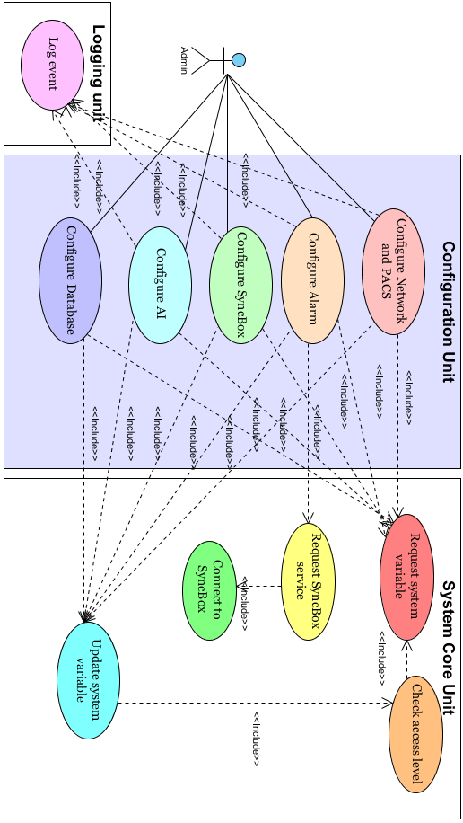

3.3.6 Use Case: Logger Unit

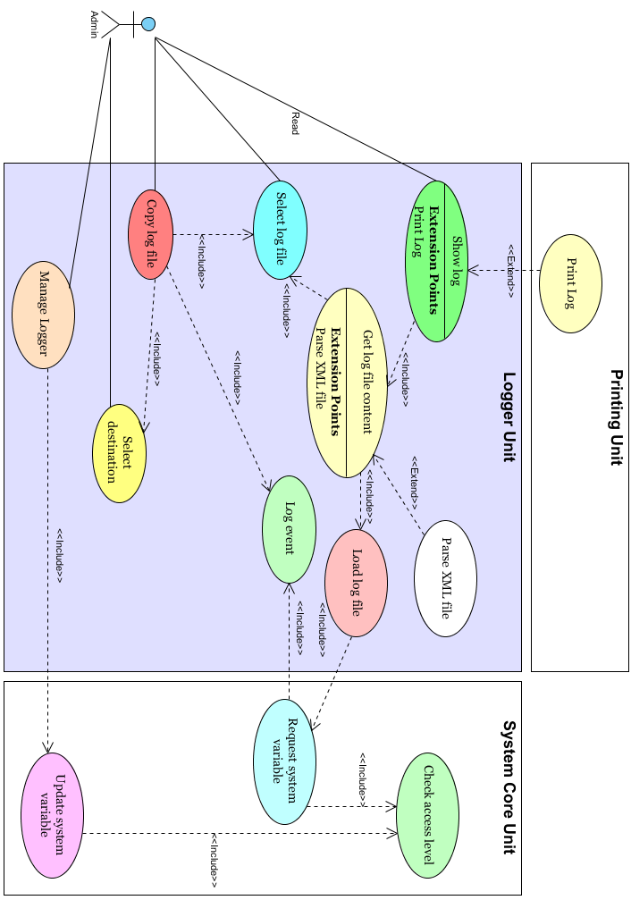

3.3.7 Use Case: Manage Account

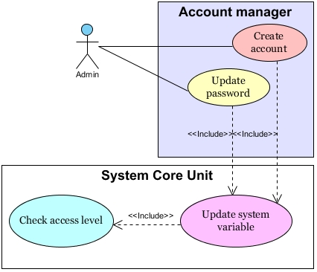

3.3.8 Use Case: Monitor Unit

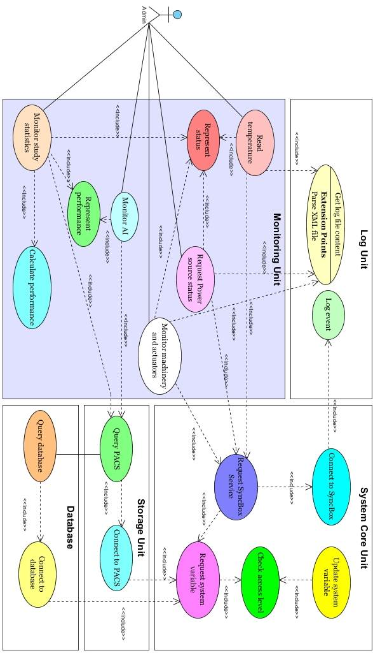

3.3.8 Use Case: Print study

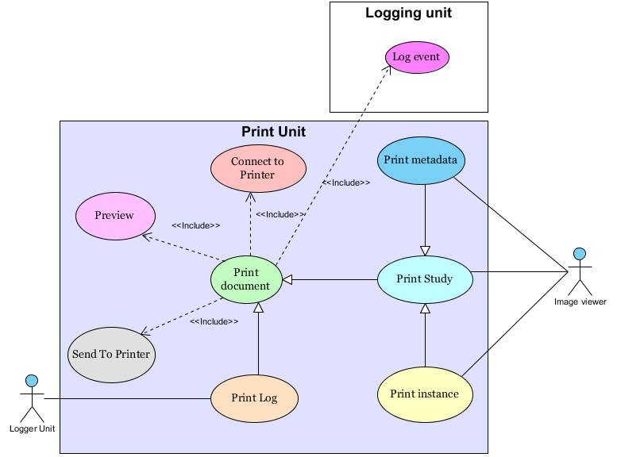

3.3.9 Use Case: Review study

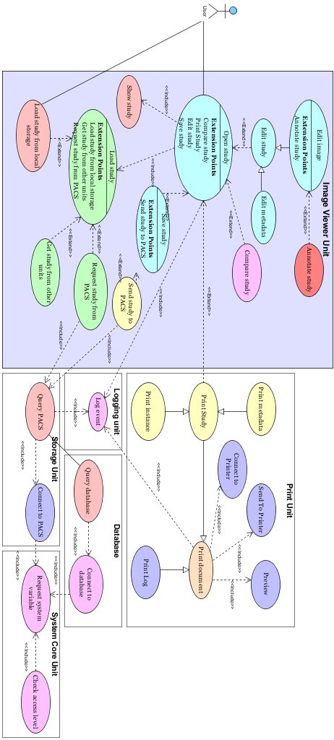

3.3.10 Use Case: Task Organizer
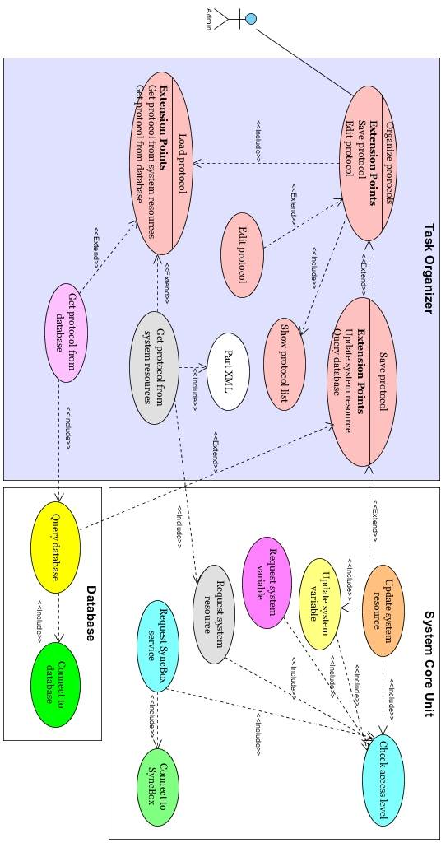

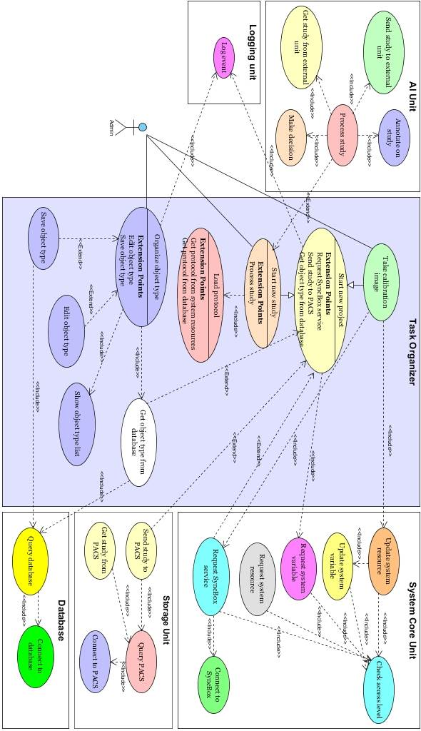

3.3.11 Use Case: Search
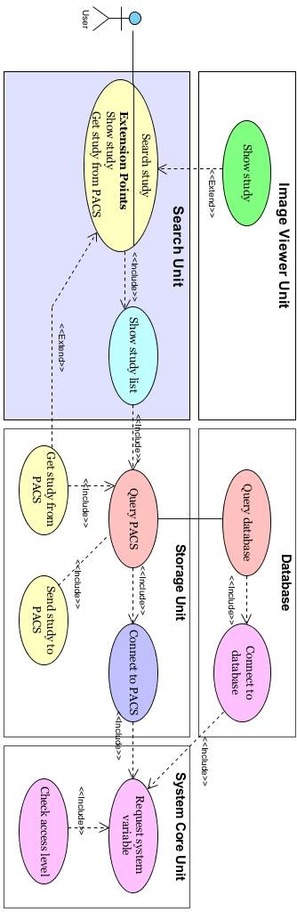

3.4 Objects
Configuration parameters are stored with in system variables. This parameters are saved under different keys. Following figure shows structure.

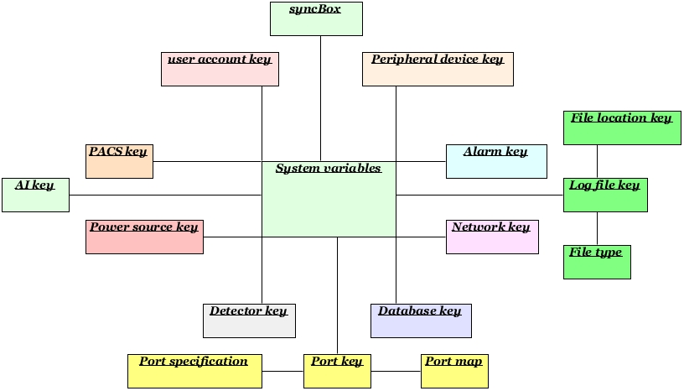

3.5 Non-Functional Requirements
Some functional requirements are considered during identification.

3.5.1 Performance
The system is real time. This term is interpreted in context. In some applications 1 sec (or so) average imaging time is considered real time. In the other application it may take a few minutes to process an object images.

3.5.2 Reliability
In the case of emergency a push bottom is pressed by the user this bottom stops the system completely.

3.5.3 Availability
Nothing.

3.5.4 Security
Nothing.

3.5.5 Maintainability
Nothing.

3.5.6 Portability
Nothing.

3.6 Inverse Requirements
The program should be written in such a way that no way it is patchable.

3.7 Design Constraints
If the iBEX is going to be used on portable device then some modules and unites are not needed to run. Also, if a device is changed then it is just enough to put s new dll files into appropriate folder. The system automatically updates the menus.
Database and or PACS services may be turned down in portable devices.
The system should use office 2007/ 2013 style ribbon bars. Also some critical reports should be shown by means of graphical interfaces.

3.8 Logical Database Requirements
System uses two database:
PACS storage server
SQLite
The first one is used to store studies but the second one is used to keep object type, AI and protocols.

3.9 Other Requirements
Color and artistic design should be approved by a professional body.

